| **Test Name** | | | Test the player’s symbol selection | | | |
| --- | --- | --- | --- | --- | --- | --- |
| **Use Case Tested:** | | | T001_Run2: Player’s symbol selection | | | |
| **Test Description:** | | | Test the simulation of player symbol selection. | | | |
| **Pre-conditions** | | | Run the program to simulate the gameplay of Crown & Anchors. Each turn, the player should pick one of the six symbols (**ANCHOR, DIAMOND, CROWN, HEART, CLUB or SPADE**) | | | |
| **Post-conditions** | | | The program should pick different symbols for each bet. It is expecting some exceptions. | | | |
| **Notes:** | | **New bug has been discovered. The SPADE symbol is never selected in a roll. Also I noticed that the player’s symbol selection never pick the SPADE symbol.** | | | | |
| **Result (Pass/Fail/Warning/Incomplete)** | |  | | | | |
|  | **TEST STEP** | | | **EXPECTED TEST RESULTS** | P | F |
|  | Run the program with pre-entered player’s details:  Player name = “Fred”  Balance = 100  Limit = 0  Bet = 5 | | | Console opens and show the result for 100 games. | P |  |
|  | Look at each individual game. Check if the symbols are different. | | | Each game should show different symbols in most of the turns. | P |  |
|  | Run the program again to check the symbols on each turn. | | | Each turn has different symbols. | P |  |
|  | Look at each individual turn. Check if SPADE is selected in any of the one hundred games. | | | ANCHOR, DIAMOND, CROWN, HEART, CLUB or SPADE is selected on each roll. |  | F |
|  | Look at each individual player bet’s symbol. Check if SPADE is selected in any of the one hundred games. | | | ANCHOR, DIAMOND, CROWN, HEART, CLUB or SPADE is selected on each roll. |  | F |

|  |  |  |  |  |  |
| --- | --- | --- | --- | --- | --- |
| **Test Data Table** | | | | | |
|  | **1** | **2** | **3** | **4** | **5** |
| Player | “Fred” | “TestPlayer” |  |  |  |
| Balance | 100 | 20 |  |  |  |
| Limit | 0 | 0 |  |  |  |
| Bet | 5 | 4 |  |  |  |

Bug Screenshots:

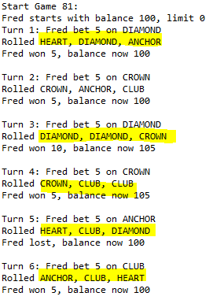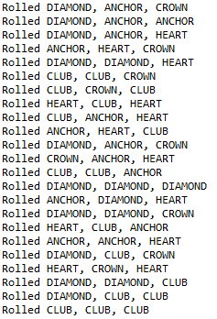

The SPADE symbol is never selected as a bet’s symbol.